Sacrifice fly

According to rule 9.08(d) of the OBR: Score a sacrifice fly when, before two are out, the batter hits a ball in flight handled by an outfielder or an infielder running in the outfield in fair or foul territory that
- is caught, and a runner scores after the catch, or
- is dropped, and a runner scores, if in the scorer's judgment the runner could have scored after the catch had the fly been caught.
Comment: The official scorer shall score a sacrifice fly in accordance with Rule 9.08(d)(2) even though another runner is forced out by reason of the batter becoming a runner.
The rules specify that the hit must be caught in the outfield, and for this reason a sacrifice fly must be credited even if the ball is caught by an infielder running in the outfield. This applies particularly to the shortstop who, because of the nature of the position, often plays well back on the edge of the red dirt and can therefore, by running quickly, reach the outfield to catch a fly ball.
A sacrifice fly (like a sacrifice hit (bunt)) does not count as a time at bat. The abbreviation for a sacrifice fly is “SF” followed by the number of the fielder who made the putout.
Example 15: A high ball to the center field becomes a sacrifice fly as it allows the runner on third base to score. Obviously, the runner on third waited until the ball had been caught before leaving the base, otherwise he would have been called out on appeal and cancelled out the sacrifice fly.
IMPORTANT: While a sacrifice hit (bunt) is credited if it enables a runner to advance a base, a sacrifice fly is credited only if it enables a runner to reach home base.
WBSC |  | Traduction dans l’outil de scorage |  | Outil
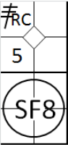 |  | /* Le premier batteur frappe un triple dans le champ droit */  action { batter -> 3BRC }  /* Le frappeur frappe une fly ans le champ centre qui est rattrapée de volé par le défenseur, le coureur marque le point */  action { batter -> SF8 , runner3 -> + } |  | 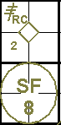
A sacrifice fly is credited even if the ball is dropped by the fielder provided that, in the scorer’s opinion, the runner could have scored a run even without the error.
Example 16: Sacrifice fly to the left fielder, who drops the ball. As you can see, the advance by the runner to home base is annotated with the batting order number of the player who hit the sacrifice fly. Even though there has been an error which allows the batter-runner to occupy first base, the batter-runner is not charged with a time at bat.
WBSC |  | Traduction dans l’outil de scorage |  | Outil
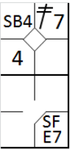 |  | /* Le premier batteur frappe un double dans le champs gauche */  action { batter -> 2B7 }  /* Le coureur en 2 vole la troisième base */  action { runner2 -> SB }  /* le batteur frappe une fly dans le champ. Le défenseur commet un erreur en rattrapant la balle, le coureur marque le point */  action { batter -> SFE7 , runner3 -> +} |  | 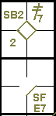

Example 17: A sacrifice fly also occurs when the ball is hit into foul territory in the outfield. Indeed, a catch by an outfielder in foul territory puts the runners back into play, and they may try to advance.
The abbreviation “FSF” is used to designate a sacrifice fly in foul territory.
WBSC |  | Traduction dans l’outil de scorage |  | Outil
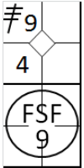 |  | /* Le premier batteur frappe un triple dans le champ droit */  action { batter -> 3B9 }  /* le deuxième frappeur frappe une fly dans le champ droit dans la zone des fausses balles, et le défenseur rattrape la balle de volé */  action { batter -> FSF9 , runner3 -> + } |  | 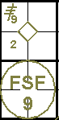
A sacrifice fly must be credited if it enables a runner to score a run, even if another runner is tagged out at a base he was trying to reach.
Example 18: The center fielder, after catching a fly ball, assists the second baseman in time to put out the runner on first, while the runner on third reaches home base. This is noted as a double play.
WBSC |  | Traduction dans l’outil de scorage |  | Outil
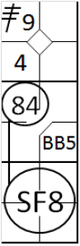 |  | /* le premier frappeur frappe un triple dans le champ droit */  action { batter -> 3B9 }  /* Le deuxième frappeur arrive sur bse su un 'base on ball' */  action { batter -> BB }  /* Le frappeur frappe une fly dans le champ centre, le défenseur attrape la balle de volée. Le défenseur renvoie la balle au défenseur de la deuxième base pour retirer le coureur arrivant de la 1. Le coureur en troisième abse en profite pour marquer le point */  action { batter -> SF8 , runner1 -> 84 , runner3 -> + } |  | 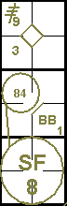
If the defense had already made a putout, the run would have to be scored before the out on second base (third putout), otherwise no run would have been scored and it would not be a sacrifice fly.
A sacrifice fly must also be credited if the ball is dropped by the defense and a runner is forced out, so long as the runner on third scores.
Example 19: The center fielder, after having dropped the ball, forces the runner out on second, while the other runner scores. In this case no error is charged to the outfielder, in accordance with rule 9.12(d)(4) of the OBR.

WBSC |  | Traduction dans l’outil de scorage |  | Outil
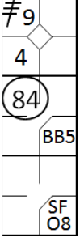 |  | /* le premier frappeur frappe un triple dans le champ droit */  action { batter -> 3B9 }  /* Le deuxième frappeur arrive sur bse su un 'base on ball' */  action { batter -> BB }  /* Le frappeur frappe une fly dans le champs centre, le défenseur attrape la balle de volée mais ma laisse retomber. Le défenseur renvoie la balle au défenseur de la deuxième base pour retirer le coureur arrivant de la 1. Le coureur en troisième base en profite pour marquer le point */  action { batter -> SFO8 , runner1 -> 84 , runner3 -> + } |  | 